ROYAL OAK INTERNATIONAL SCHOOL
SR. SEC. CBSE AFFILIATED
HOLIDAY HOME WORK (SESSION 2018 - 19)
Class VIII
Name ____________________ Roll No. __________ Sec._______
Please note the following :
- Summer vacations will commence from 17th May 2018(Thursday) till 29th June 2018(Friday) both days inclusive.
- The school will re-open on 2nd July, 2018(Monday)
- Schedule for the submission of HHW for all class is as follows :
English : 09/07/2018
Hindi : 10/07/2018
Maths : 11/07/2018
Science : 12/07/2018
SSt. : 13/07/2018
- For Computer, Sanskrit, Art & Craft (2nd week of july) dates will be given in the classes only by the subject teachers.
- Summer HHW -5marks will be added as an Activity marks in Term - I

WISHING YOU ALL A VERY FRUITFULL AND ENJOYABLE VACATION
HAPPY HOLIDAYS
Attached

English

Q1. Make a beautiful bookmark for your Literature reader. Decorate it and write a famous quotation by a well know poet or author.

Q2. Make a poster on any of the following topics on an A-3 size pastel sheet
a) Donate blood b) Keep the earth green c) Save water d) Save girl child
e) Stop violence against women

Q3. Practice your grammar skills throughout the holidays in - Together With English.
Topic Page No.
Tense C- 37 to 40
Determiners C- 5,6,14 &15
Preposition C – 30 to 34

Q4. Interview your parents / grandparents to find out about the things they used to do when they were your age which no longer exist/ no longer followed or done.
Eg. Leisure time activities
Games
Customs practiced etc.
Minimum 10 questions.
Make it interesting. Your interview must have a lot of details for the reader to understand the yesteryears clearly. Have fun!

Q5. Do the worksheet attached.

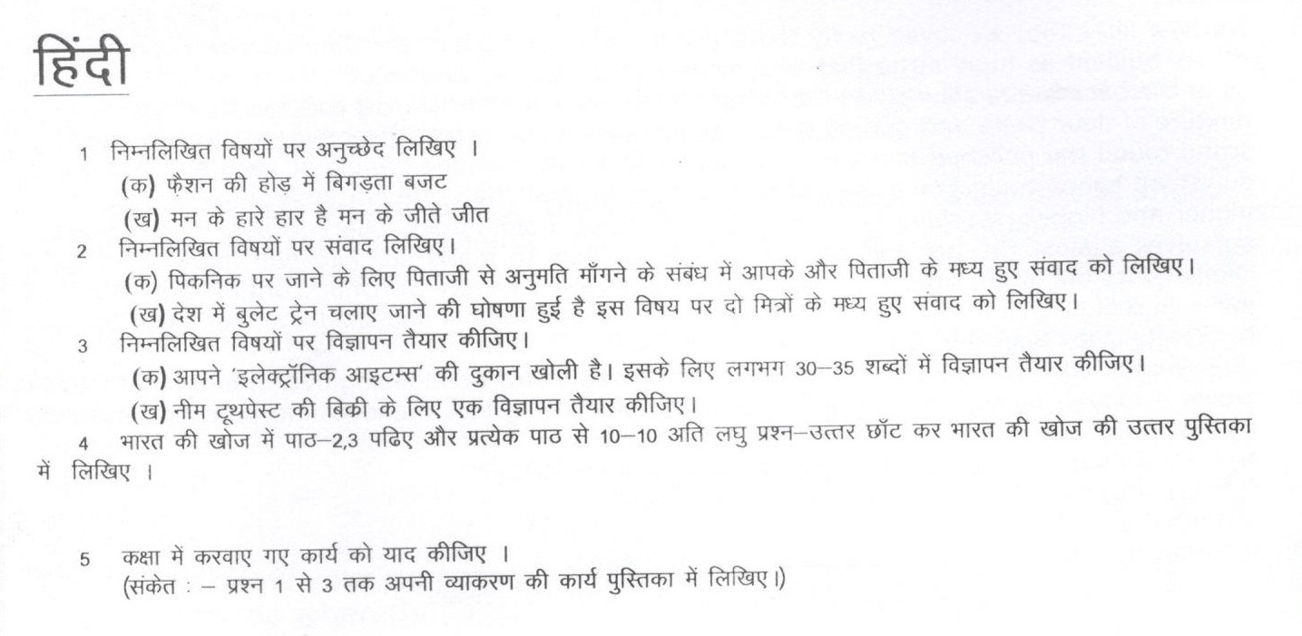
Maths
The sum of two numbers is $\frac{5}{9}$ . If one of the number is $\frac{1}{3}$ , Find the other. (Ans : $\frac{2}{9 }$)
Q-2 What should be added to $\frac{-7}{8}$ so as to get $\frac{5}{9}$ ? (Ans : $\frac{103}{72 }$)
Q-3 By what number should we multiply $\frac{3}{-14}$ , so that product may be $\frac{5}{12}$. (Ans : $\frac{-35}{18 }$)

Q-4 Find ten Rational number between -2 and 5.

Q-5 Solve the equation and check the result : $\frac{x}{5}$ + 11 = $\frac{1}{15}$.
Q-6 Solve : (i) $\frac{17-3x}{5}$ - $\frac{4x+2 }{3}$ = 5 – 6x + $\frac{7x+14 }{3}$. (ans =4) (ii) $\frac{2x+5}{3}$ = 3x – 10 (ans = 5)
Q-7 Two numbers are such that the ratio between them is 3:5. If each is increased by 10, the ratio between the new
numbers so formed is 5:7. Find the original numbers. (ans 5, 15,25)
Q-8 Three prizes are to be distributed in a quiz contest. The value of the second prize is five – sixths the value of the
first prize and the value of the third prize is four – fifths that of the second prize. If the total value of three prices
is RS 150, Find the value of each prize. (ans : 60 , 50,40
Q-9 A number consists of two digits whose sum is 8. If 18 is added to the number its digits are reversed. Find the
Number. (ans: 5 , 35)
Q-10 Kanwar is three years older than Aman. Six years ago, Kanwar’s age was four times Aman’s age. Find
the ages of Kanwar and Aman. (ans :7,10)
Q-11 Verify : $\frac{5}{3}$ $×$ ($\frac{-2}{5}$ + $\frac{-9}{10})$ =$\frac{5}{3}$ $×$ $\frac{-2}{5}$ +$\frac{5}{3}$ $×$ $\frac{-9}{10})$
Q-12 Using distributivity , find ($\frac{9}{16}×$ $\frac{4}{12})$+ ($\frac{9}{16}×$ $\frac{-3}{9})$
Q-13 The present ages of two children Shikar and John are in the ratio 5:8. Four years later the sum of their
ages will be 34. Find their present ages. (ans: 2,10,16)
Q-14 One of the two digits of a two digit number is two times the other digit. If we interchange the digits of this
two – digit number and add the resulting number to the original number , we get 99. What is the original
number? (ans: 3,63)
Q-15 The present ages of Rachna and Vandana are in the ratio5;7. Yen years from now, their ages will be in the ratio
7:9. Find their present ages. (ans: 5,25years , 35years)
Q-16 Udita’s father present age is five times her present age. Two years from now, Udita’s age will be one
fourth of her father’s present age. Find bpth Udita’s and her father’s present ages. (ans: 8,40)
Q-17 Rashmi is a cashier in a bank. She has currency notes of dominations Rs 100, Rs 50 and Rs 20. The
ratio of the number of notes is 5:3:2. The total amount with Rashmi is Rs 1,38,000. Find the number of
notes of each domination she has. ( ans: 200, 1000,600, 400)
Q-18 Do atleast 5 questions from each chapter of NCERT EXEMPLAR (Chapter 1,2,3)
Q-19 Draw solid figure shape in 2- D and 3-D in a scrap book of Square, Rectangle, Triangle, Circle, Cuboid, cube,
sphere, cylinder, cone) by using ice cream sticks , coloured paper , etc ) and write and learn the formula for
each shape : ( Perimeter ,circumference, surface area, volume)
Q-20 Activity 1: Fold a paper 8 times in any way. Unfold and locate various convex and concave polygons.( In a chart paper.)
Science
Worksheet on Synthetic Fibers and Plastics
Q1. Fill in the blanks:-
1. Clothes are made up of ______________ which are made from __________.
2. The polymer cellulose is made up of a large number of ________________ units.
3. Silk fibre is obtained from _____________ whereas artificial silk is obtained by chemical treatment of _______________.
4. The polymer polyester is made up of repeating units of ______________.
5. Synthetic fabrics soak _____________ water than the natural fabrics and take ______________ time to dry.(less/more)
6. Polythene which is used to make polythene bags is an example of a ________.
7. Iron rusts when it is exposed to ______________ and _____________.
8. Plastics do not react with ______________ and __________________.
9. Plastics are generally ___________________ than metals.
10. ________________ is a special plastic on which oil and water do not stick.
Q2. Write one use of following fibres.
1) Rayon 2) Nylon 3) Polyester 4) Acrylic
Q3. Answer the following questions:-
1. Name a fibre having properties similar to that of silk.
2. Although rayon is obtained from a natural source, wood pulp, yet it is a man-made fibre. Why?
3. Why does Nylon become very popular for making clothes for mankind?
4. Is nylon fibre really so strong that we can make nylon parachutes and ropes for rock climbing?
5. Why does polyester fibre quite suitable for making dress material?
6. Name a form of polyster which is used for making bottles, utensils, films, wires and many other useful products?
7. Why synthetic fibres are more popular than natural fibres?
8. Identify the Synthetic fibre appears to resemble wool?
Activity: Classify various types of synthetic fibres with their sources and paste the samples on A3 size sheet using tags.

SOCIAL SCIENCE
- Prepare a project file on the topic “Non-Conventional Sources of Energy”.
(Decorate your project file in a decent manner)
Must begin the project by including the following parameters :
- Cover page with your name , roll no, academic year.
- Index
- Acknowledgement ( giving credit to those who helped you in this project)
- Map related to the project
- Introduction - Project overview ( brief idea about the project )
- Content sheet ( 8 to 10 with relevant photographs )
( Recent development , Innovative techniques to harness energy, Distribution in the world )
- Conclusion
- Source of information -Bibliography ( the book you read and the website you visited for the project )
Roll no. 1- 8 : Tidal Energy
Roll no. 9- 16 : Nuclear Energy
Roll no. 17- 24 : Geo thermal Energy
Roll no. 25 onwards : Wind Energy

- Design a logo and Manifesto for his/her Political party in fair notebook of Pol. Sc.
- Prepare complete syllabus for Periodic Assessment I .

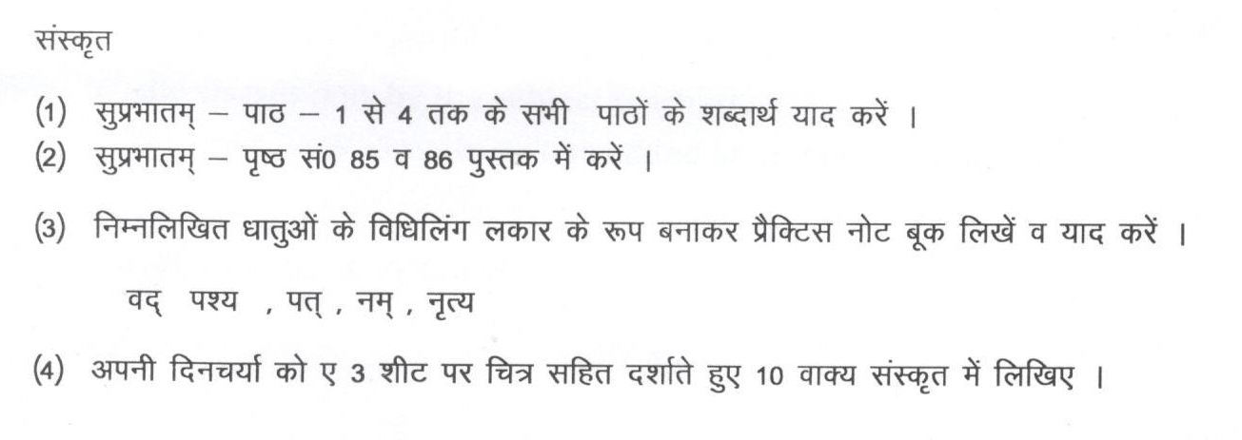

Computer
Roll No. (1 to 11):- Write different type of Data Type in MS Access and explain. On A3 Sheet.
Roll No. (12 to 23):- Writeadvantages of Database.On A3 Sheet.
Roll No. (24 onward):- Write Database Objects and Naming a Field. On A3 Sheet.
1) Make a PowerPoint Presentation (at least 10 slides) and take a printout of it.
Roll No. (1 to 11):- Life without Technology.
Roll No. (12 to 23):- Cyber Crime
Roll No. (24 onward):- Effect of Social Networking (Good and Bad)

- Write all the shortcut keys of MS Access in your Computer Notebook and Lesson 1 and 2.

Art/Craft
Summer Break : Flower Vase

